WEB APP ASSIGNMENT

Group No: F362-DG01

Content Page

1. Application Requirement and Specifications………………………………………....3
2. Functional Requirement and Specifications…………………………………………..3
3. Design of web application

-Site Map……………………………………………………………………...4

-StoryBoard………………………………………………………………….5-6

-WireFrame…………………………………………………………...……..7-10

**1. Application Requirements and Specifications**

R1. Allow for customers to browse different categories of products and details within the online shop

R2. Allow for online purchase of the products

R3. Acknowledgement of the order through email

R4. Allow for request of update of the order through email

**2. Functional Requirements and Specifications**

F1. In the products page, the product will be sorted by the different categories of products (Speakers, Keyboards etc.), with the details and descriptions of the product under each image.

F2. The website will have a add to cart feature, with the customer entering the address and credit card details etc. Customer will have to register an account and log in before purchase.

F3. Upon purchase and confirmation, a confirmation email containing the details of the order will be sent to the customer.

F4. Upon login into their account by the customer, the customer will be able to request an email update of their order by entering their order number into the text-field.

1. **Design of web application**

**-Site Map**

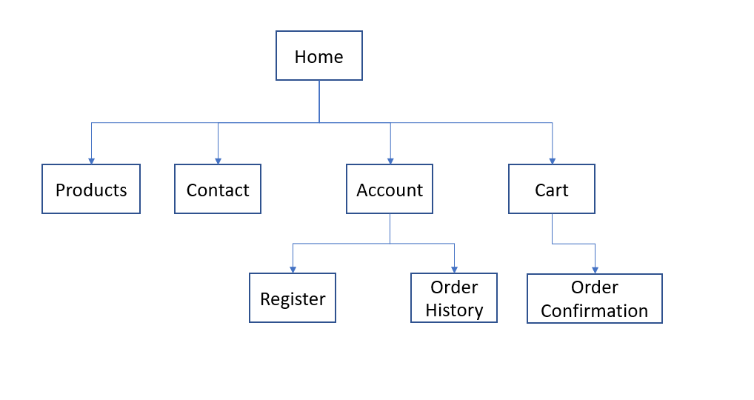

**-StoryBoard**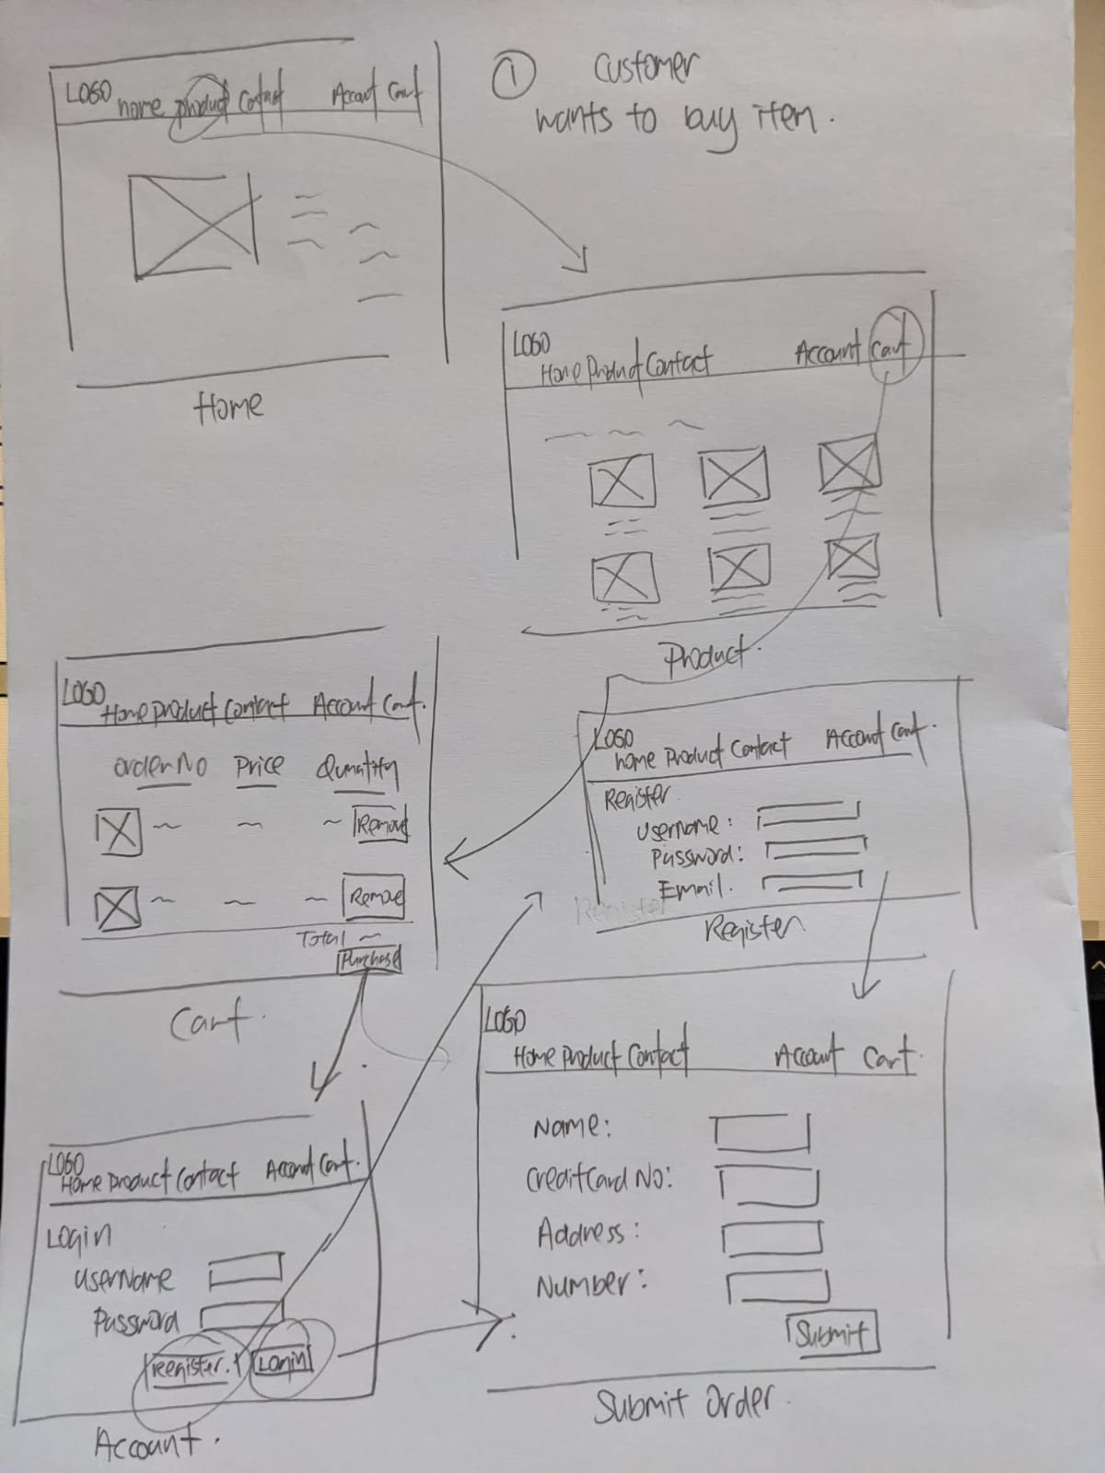

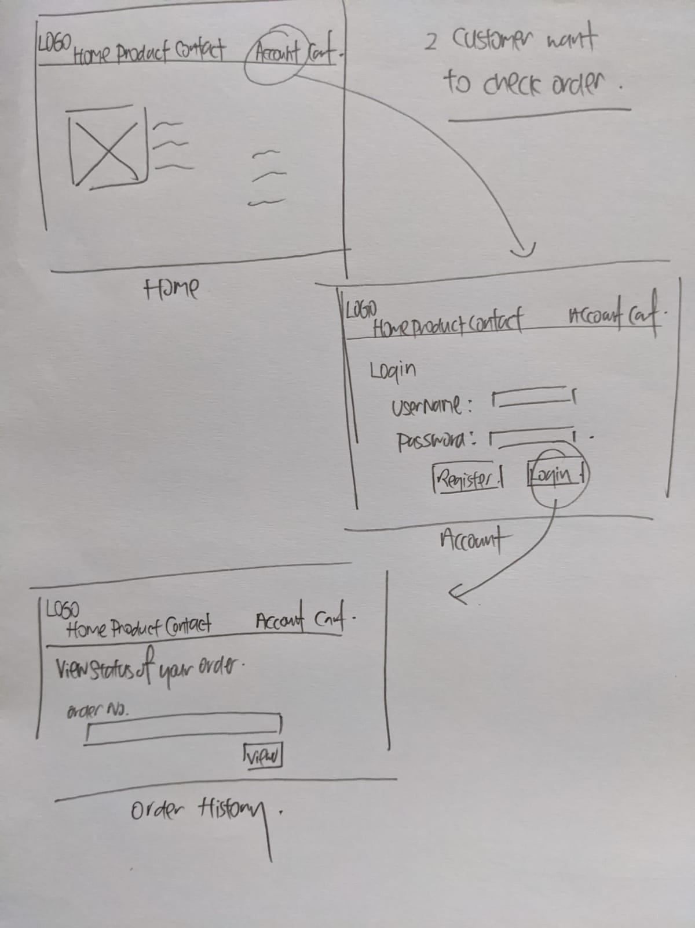

**-WireFrame**

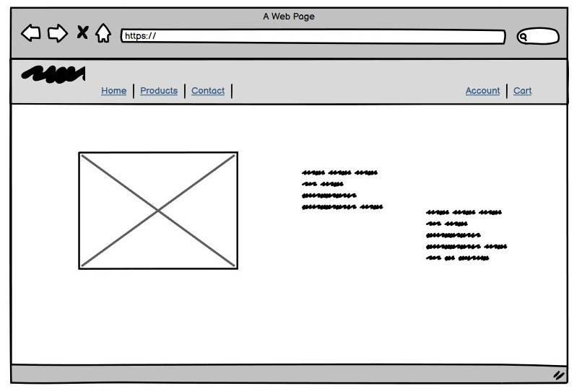

Home

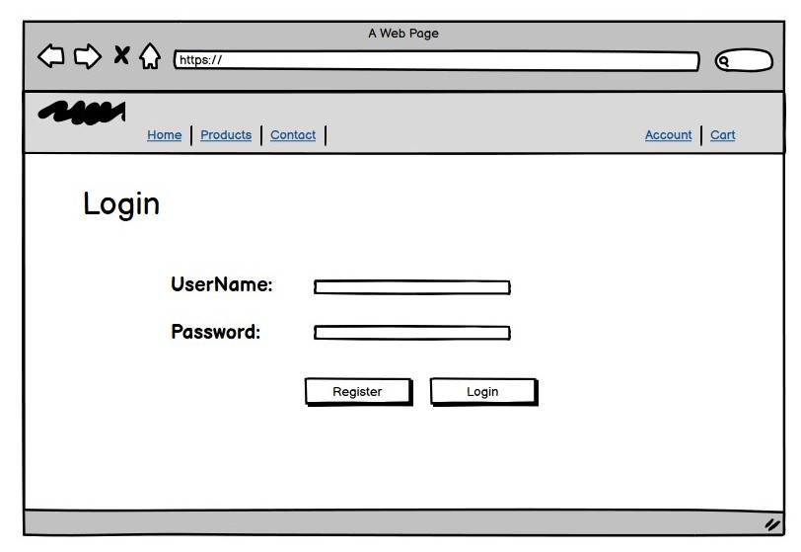

Login

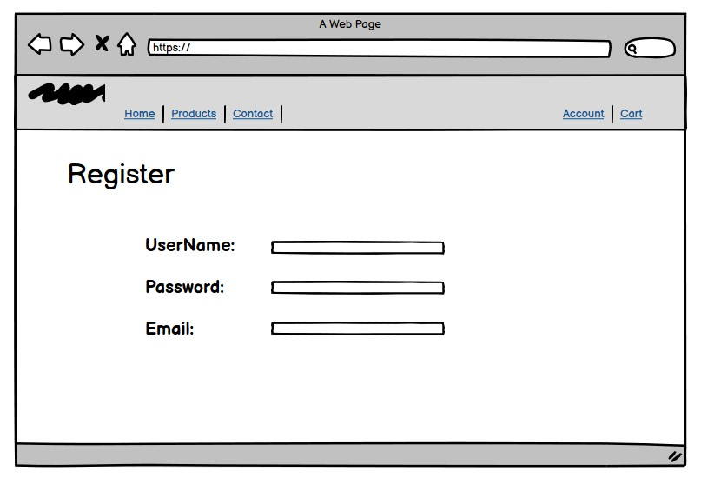

Register

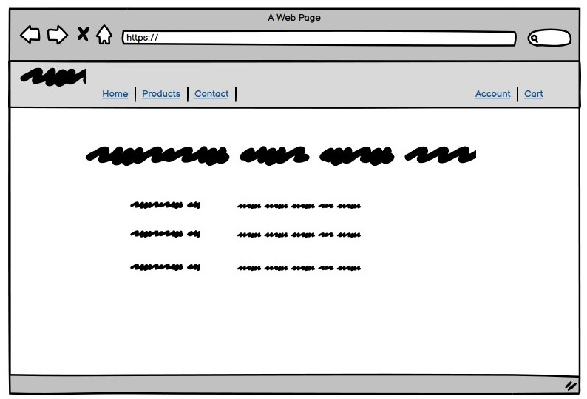

Contact Us

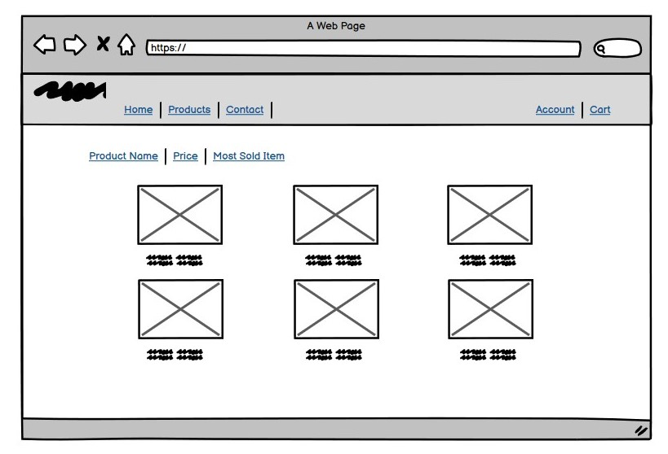

Product

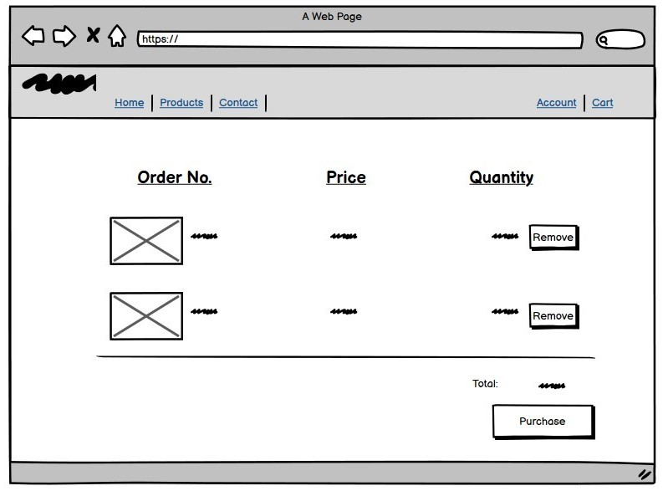

Cart

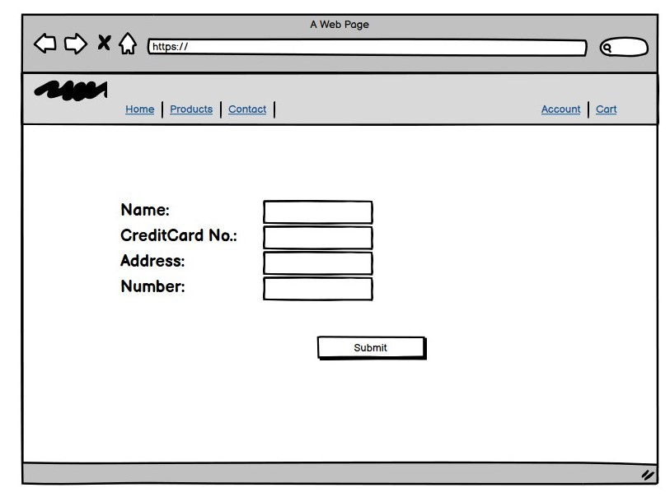

Submit Order

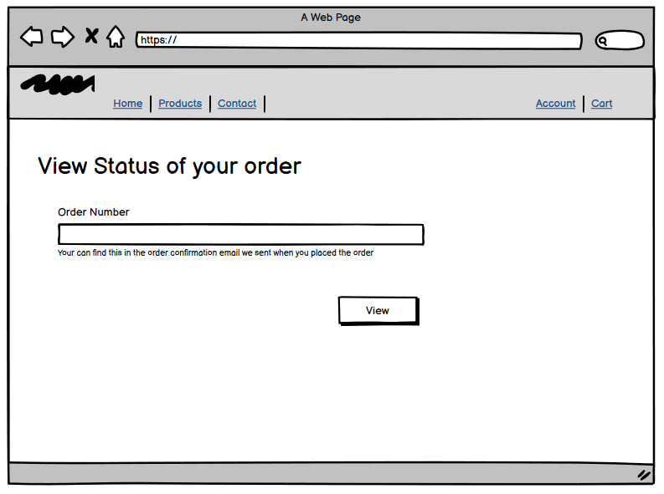

Order History